**Sensor in car**

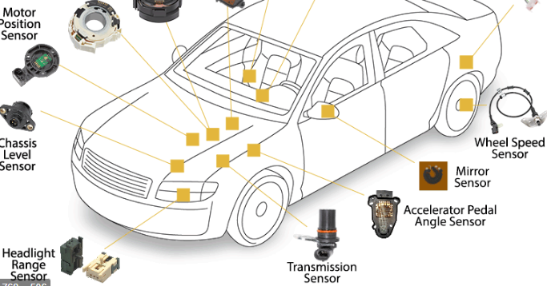

A car sensor is an electronic device that monitors various aspects of the vehicle and sends information to the driver or ECU (Electronic Control Unit). In certain situations, the ECU automatically makes adjustments to the particular component based on the information received from the sensor.

* Sensors are made life easy for drivers.
* Faulty components are easily detected
* Automatic control is common with vehicles that feature sensors.
* The engine is properly maintained with the devices.
* Every adjustment is done precisely with sensors.
* The driver receives warming information on bad components.

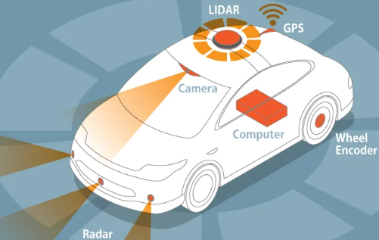

<https://studentlesson.com/car-sensors-definition-functions-diagram-types-working/>

<https://ackodrive.com/car-guide/different-types-of-car-sensors/>

***sensors in cars***

A car sensor is an electronic device that monitors various aspects of the vehicle and sends information to the driver or ECU (Electronic Control Unit). In certain situations, the ECU automatically makes adjustments to the particular component based on the information received from the sensor. The below points cover more details about car sensors.

The first car sensor was invented in 1995 by George Platzer and it’s a blind spot detection sensor, which is a sensor placed in the car to warn the driver of other cars that are traveling next to the driver or behind him, and these warnings are either visual, or audible, or by vibration or touch,It is being developed to this day so that it senses all directions of the car.

**Uses of sensors in cars:**

• Sensors  made life easy for drivers.

• Faulty components are easily detected

• Automatic control is common with vehicles that feature sensors.

• The engine is properly maintained with the devices.

• Every adjustment is done precisely with sensors.

• The driver receives warming information on bad components.